Setup
The Husqvarna Robot is designed to work with Ubuntu 16.04 and ROS kinetic (follow the instructions here http://wiki.ros.org/kinetic/Installation/Ubuntu), and Ubuntu 16.04. These should both be installed on your computer or in a virtual machine. After installing ROS, the following packages are also recommended installation material (Note: replace indigo with kinetic). Doing the Beginner Tutorials on ROS is also a good idea (http://wiki.ros.org/ROS/Tutorials) .
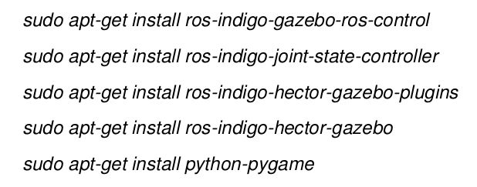

Important Information from the beginner tutorials
Install the beginner tutorials package (replace distro with kinetic)
Add the following to your .bashrc file (located at ~/.bashrc) so you don’t have to re-run these commands each time you want to use ROS.
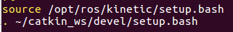

These can also be added using the command line
$ echo “source /opt/ros/kinetic/setup.bash” >> ~/.bashrc
$ echo “. ~/catkin_ws/devel/setup.bash” >> ~/.bashrc
Note: any commands in bashrc don’t take effect in open terminals unless reloaded with source ~/.bashrc )

Create a catkin workspace
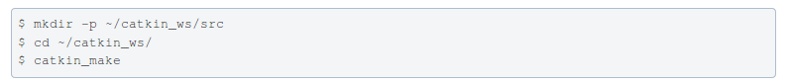
This can also be done using
Whenever you want to re-build the catkin workspace run:
All new ROS workspaces should be placed inside the src folder of catkin_ws. For example to create a beginner tutorials workspace run inside ~/catkin_ws/src
There is more information about using ROS Nodes in beginner tutorials

Get the HRP files
1. Go to the Husqvarna Github page (https://github.com/HusqvarnaResearch/hrp) and copy the link to clone their files
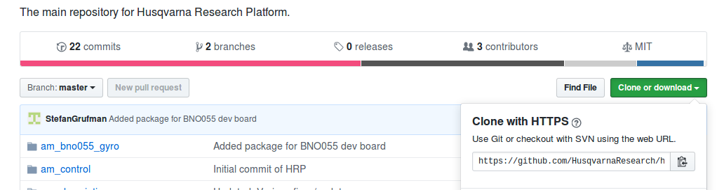
2. It might be useful to download and save the “Start-up Guide HRP” file, which has Husqvarna’s instructions for running the lawn mower.
3. Navigate to ~/catkin_ws/src your catkin workspace and run the following (i.e. copy the git repository into this folder)
$ git clone https://github.com/HusqvarnaResearch/hrp.git
Troubleshooting
- Check that you have git installed (sudo apt-get install git), or replace the url with the one you copied in step 1.
4. Navigate back to catkin_ws and run catkin_make
- This will very likely fail, with some error message about not being able to find a configuration file from a certain ROS package. Google that package, and install it.
- If it fails in another manner, try the forums

Controlling the Lawnmower Through Wifi
1. Connect to the Husqvarna Wifi
- The Network will be titled: HRP_LTH_1
- The password is 1234567890
Troubleshooting:
- If you cannot see the wifi: wait a few moments (it may take time to boot up). If this doesn’t work, disassemble the robot (remove the charging cord, take the black lid off and unscrew the top part of the gray casing). The device emitting the wifi is a USB key plugged into the beagle-bone black. Press the WPS button on this until the blue light on the USB turns on.
- The password doesn’t work or it won’t connect: This is probably not because the password is wrong, but because some computers/operating systems/ wireless cards don’t want to/ can’t connect to WPS wifi (some security protocal? They only work with WPA? Not sure why). Try another operating system or computer.
  - MAC OS: doesn’t work (both iphones, macs, and macs running a linux virtual machine)
  - Android phone: Works
  - Windows running Ubuntu virtual machine: Works
  - Ubuntu: sometimes works.
- It says connected, but no Internet: this is fine. You can’t use a browser, but you can operate the robot.
2. Start the lawnmower
- Turn on the lawn mower using the on switch and open the control panel lid
- Activate the robot by entering the pin: 1111
- Enter menu

- To set it up so it doesn’t need a boundary wire press and hold the buttons 7 and 9 simultaneously until the following symbol for the tools menu appears
- sssssssssssPress Start
- Close the control panel lid

3. SSH into the Robot
- ssh into the robot on your computer using
ssh ubuntu@192.168.100.1
  - The password is: ubuntu (no capitals)
Troubleshooting:
- The following error, ssh: connect to host 192.168.100.1 port 22: No route to host is shown.
  - CHECK that you are sshing to the right IP address.
  - Try opening the casing and making sure the USB is plugged into the Beaglebone properly. You could also press the WPS button on the USB key a few times.
  - If you are working in a virtual machine. Check that your IP address begins with 192.168. You must be using a bridged adapter connection which allows the virtual machine to have a distinct IP address from the host computer. Try restarting the virtual machine – sometimes it takes longer to recognize a change in wifi networks than the host.
4. Launch the master node
- In the terminal of the lawnmower (i.e. the one in which you are ssh) run:
- $ roslaunch am_driver_safe automower_hrp.launch
5. Configure the network
- Only necessary if you haven’t connected to the robot before
- Open a new terminal (i.e. a non lawn mower terminal)
- Add the following lines to the end of your /.bashrc file (where 192.168.X.X is your IP addresss)
export ROS_MASTER_URI=http://192.168.100.1:11311
export ROS_IP=192.168.X.X
export ROS_HOST_NAME=”192.168.X.X”
- Run the source ~/.bashrc command in your terminal
- Close the terminal
Troubleshooting
    - ifconfig should produce your IP address. Your can also try hostname -I

6. Launch nodes
- Open a new terminal on your computer
- Launch your chosen node
- Examples
  - rosrun am_driver hrp_teleop.py
Troubleshooting
- Can’t find master node: the ROS_MASTER_URI was probably set incorrectly. Try printenv ROS_MASTER_URI to check the value.
- If the robot doesn’t move after the node is launched, open the lid, press start and close it again.
- Warning: Clock skew detected. This won’t harm anything, but you can run
sudo date MMDDhhmmyyyy.ss
  - You can also try the folowing if there is internet, (install ntp first)
ntpdate -s ntp.ubuntu.com
- This error will probably appear in the lawnmower terminal– it is because the hrp files downloaded on the beaglebone or lawnmower system are an older version than the ones you cloned to your computer. DON’T WORRY about it. It shouldn’t cause any problems (at least, it didn’t at the time I was using it). If it begins to, you may needed to open the casing, connect the beaglebone to the internet and re-download the files from gitHub into the appropriate folder.
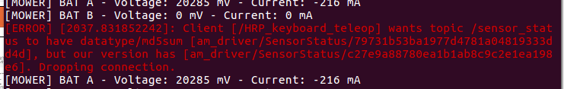

Controlling the Lawnmower Through A USB Cable
sudo gpasswd --add ${USER} dialout
Starting the mower
- Access the control panel by pressing the STOP button
- Enter the PIN securities setting and enter the pin 1111
- Press the "MENU" button once to access the menu
- Press and hold "7" and "9" simultaneously until a new item pops up in the menu in the shape of a wrench (press down twice to see it)
- Press "OK" to access the hidden menu
- Navigate to "Special Settings" and press "OK"
- Press "OK" to select "Override loop detection"
- Press "OK" to confirm this setting
- Plug one end of the USB cable into the bottom of the robot (the square end), and the other into your laptop
- Press "BACK" multiple times until you are back to the main menu
- roslaunch am_driver_safe automower_hrp.launch
- rosrun am_driver hrp_teleop.py / chmod +x controller.py
+ rosrun simple_controller controller.py
- Press the "START" button
- Close the lid to reload the STOP button
GitHub for version control
Initial Setup
- Create an account and repository online in GitHub
- Navigate to catkin_ws/src, and run git clone <your repository url> to copy the github repository to your local computer. If the repository is private, you will need to enter the user name and password of one of the editors
- Set the remote github repo as the orgin using git remote add <your repository url>
- git remote -v will verify if this has worked, confirming you can fetch and push to this origin.
- If you are using forks, you may also want to set it as the upstream branch (see here)
- Note: This can also be done in reverse, creating a local repository and then uploading it to the Github page (see here).
Pushing changes from local to Github
- To add files to Git’s list use git add yourfilename
- To add all changes use git add --all or git add .
- To commit these changes run git commit -m “your message”
- Run git push
- To push directly into the master branch run git push origin master
- To push into a different branch run git push
- Note: git status is useful in providing lists of files to be added/committed
Pulling from Github to local
- To push directly

Get velocities:
rostopic echo /cmd_vel

Navigation stack:01

Rviz – se what lidar is outputting?
Mapping
Localizing
Navigation
URDFI : how your robot looks

Running gazebo

1. Run Gazeebo simulation:
roslaunch am_gazebo am_gazebo_hrp.launch gui:=true
rosrun am_driver hrp_teleop.py
Running the Lidar
roslaunch hector_slam_launch tutorial.launch

https://github.com/Slamtec/rplidar_sdk

refers to:
https://github.com/slamtec/rplidar_ros
roslaunch rplidar_ros view_rplidar.launch

Tutorial:
http://wiki.ros.org/action/fullsearch/ROS/Tutorials/WritingPublisherSubscriber%28c%2B%2B%29?action=fullsearch&context=180&value=linkto%3A%22ROS%2FTutorials%2FWritingPublisherSubscriber%28c%2B%2B%29%22

Scan with lidar into hectorslam:
https://github.com/NickL77/RPLidar_Hector_SLAM
roslaunch rplidar_ros rplidar.launch
roslaunch hector_slam_launch tutorial.launch

Random:
Nvidia tx2
Model of robot: 400c

Thesis on SLAM algorithms:
http://lup.lub.lu.se/luur/download?func=downloadFile&recordOId=8915402&fileOId=8915426

Gmapping:

Read the laser and transforms from robot → create a occupancy grid map (OGM)

roslaunch gmapping slam_gmapping_pr2.launch

Rviz:
rosrun rviz rviz
Add LaserScan then add /scan as topic

Map from logged data:
http://wiki.ros.org/cn/slam_gmapping/Tutorials/MappingFromLoggedData#record

step 1) use catkin_make instead of rosmake gmapping

when generating the data I used:
rosbag record -O mylaserdata /base /tf

step 5) rosrun gmapping slam_gmapping scan:=scan (maybe unnecessary)

before step 7)
sudo apt-get install ros-indigo-map-server

Get info from bag:
rosbag info mylaserdata2.bag

ROS tf tree:
rosrun tf view_frames
evince frames.pdf

View the tree:
runsomething
rosrun tf view_frames

View the graph (super nice for seeing how nodes and topics relates):
rqt

Google Catogorpher:

https://google-cartographer-ros.readthedocs.io/en/latest/compilation.html#system-requirements

sudo apt-get update
sudo apt-get install -y python-wstool python-rosdep ninja-build
wstool init ~/Documents/HusqvarnaMowerProject/catkin_ws/src

wstool merge -t src https://raw.githubusercontent.com/googlecartographer/cartographer_ros/master/cartographer_ros.rosinstall

wstool update -t src
src/cartographer/scripts/install_proto3.sh
sudo rosdep init
rosdep update
rosdep install --from-paths src --ignore-src --rosdistro=${ROS_DISTRO} -y (NO!)
rosdep install --from-paths src --ignore-src -r -y (USED THIS)

How to run from current state of the git:
Terminal1: roslaunch nep_husq neq_husq.launch
This starts the hrp am_driver node, lidar node, hector slam node.
Terminal2: rosrun am_driver hrp_teleop.py
If you want to write scripts to control thing we have some simple examples in the package “simple_controller”. Guess they have to be modified to do anything meaningful for now. But maybe just make a new one and play around.

Install navtigation
git clone https://github.com/ros-planning/navigation.git
did not work with “catkin_make” so the below commands had to be run first before “catkin_make”.
sudo apt-get install ros-kinetic-tf2-sensor-msgs
sudo apt-get install ros-kinetic-move-base-msgs

